Setting Up Tomcat Server

For Tomcat 9 :

<https://tomcat.apache.org/download-90.cgi>

download windows service installer .

execute the same .

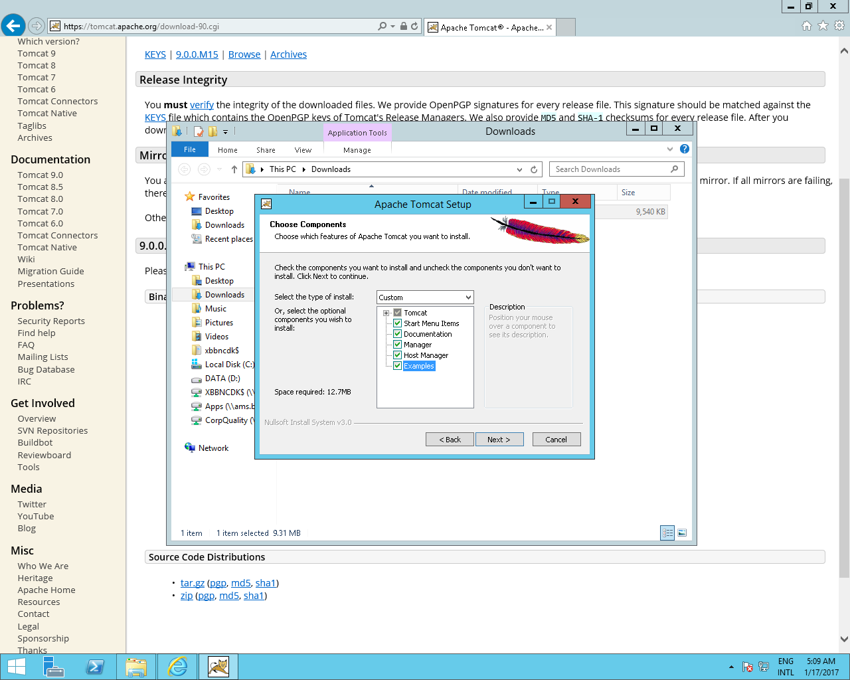

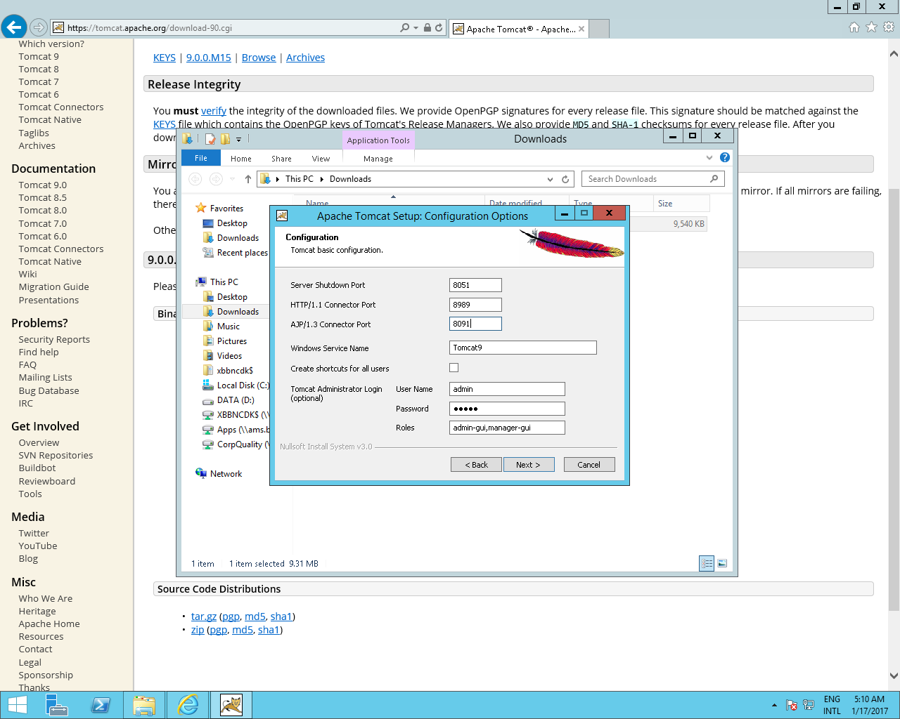

Install JDK 8

Tomcat 9 : By default the Manager is only accessible from a browser running on the same machine as Tomcat. If you wish to modify this restriction, you'll need to edit the Manager's context.xml file.

